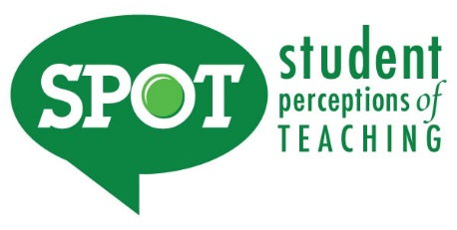

Full Term Session: August 18 – December 12
Student Perceptions of Teaching (SPOT)

Student feedback is important and an essential part of participation in this course. The student evaluation of instruction is a requirement for all organized classes at UNT. The short SPOT survey will be made available November 11 – December 04 to provide you with an opportunity to evaluate how this course is taught. For the Fall 2025 Full Term session you will receive an email on November 11 (around 3:00 a.m.) from "UNT SPOT Course Evaluations via IASystem Notification" (no-reply@iasystem.org) with the survey link. Please look for the email in your UNT email inbox. Simply click on the link and complete your survey. Once you complete the survey you will receive a confirmation email that the survey has been submitted. For additional information, please visit the spot website at https://vpaa.unt.edu/spot or email spot@unt.edu.
8W1 Session: August 18 – October 10
Student Perceptions of Teaching (SPOT)

Student feedback is important and an essential part of participation in this course. The student evaluation of instruction is a requirement for all organized classes at UNT. The short SPOT survey will be made available September 30 – October 09 to provide you with an opportunity to evaluate how this course is taught. For the Fall 2025 8W1 session you will receive an email on September 30 (around 3:00 a.m.) from "UNT SPOT Course Evaluations via IASystem Notification" (no-reply@iasystem.org) with the survey link. Please look for the email in your UNT email inbox. Simply click on the link and complete your survey. Once you complete the survey you will receive a confirmation email that the survey has been submitted. For additional information, please visit the spot website at https://vpaa.unt.edu/spot or email spot@unt.edu.
8W2 Session: October 13 – December 12
Student Perceptions of Teaching (SPOT)

Student feedback is important and an essential part of participation in this course. The student evaluation of instruction is a requirement for all organized classes at UNT. The short SPOT survey will be made available December 02 – December 11 to provide you with an opportunity to evaluate how this course is taught. For the Fall 2025 8W2 session you will receive an email on December 02 (around 3:00 a.m.) from "UNT SPOT Course Evaluations via IASystem Notification" (no-reply@iasystem.org) with the survey link. Please look for the email in your UNT email inbox. Simply click on the link and complete your survey. Once you complete the survey you will receive a confirmation email that the survey has been submitted. For additional information, please visit the spot website at https://vpaa.unt.edu/spot or email spot@unt.edu.

