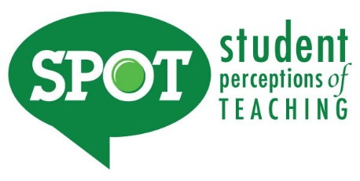
Syllabus Addendum regarding SPOT for SP20 Regular Academic Session/8W1 and 8W2

Student Perceptions of Teaching (SPOT)

Student feedback is important and an essential part of participation in this course. Providing the student evaluation of instruction instrument is a requirement for all organized classes at UNT. The short SPOT survey will be made available April 13 – April 30 to provide you with an opportunity to evaluate how this course is taught. For the spring 2020 semester you will receive an email on April 13 (12:01 a.m.) from "UNT SPOT Course Evaluations via IASystem Notification" (no-reply@iasystem.org) with the survey link. Please look for the email in your UNT email inbox. Simply click on the link and complete your survey. Once you complete the survey you will receive a confirmation email that the survey has been submitted. For additional information, please visit the SPOT website www.vpaa.unt.edu/spot or email spot@unt.edu.

Student Perceptions of Teaching (SPOT)

Student feedback is important and an essential part of participation in this course. Providing the student evaluation of instruction instrument is a requirement for all organized classes at UNT. The short SPOT survey will be made available February 24 – March 5 to provide you with an opportunity to evaluate how this course is taught. For the 8W1 spring 2020 semester you will receive an email on February 24 (12:01 a.m.) from "UNT SPOT Course Evaluations via IASystem Notification" (no-reply@iasystem.org) with the survey link. Please look for the email in your UNT email inbox. Simply click on the link and complete your survey. Once you complete the survey you will receive a confirmation email that the survey has been submitted. For additional information, please visit the SPOT website at www.vpaa.unt.edu/spot or email spot@unt.edu.
Student Perceptions of Teaching (SPOT)

Student feedback is important and an essential part of participation in this course. Providing the student evaluation of instruction instrument is a requirement for all organized classes at UNT. The short SPOT survey will be made available April 27 – May 7 to provide you with an opportunity to evaluate how this course is taught. For the 8W2 spring 2020 semester you will receive an email on April 27 (12:01 a.m.) from "UNT SPOT Course Evaluations via IASystem Notification" (no-reply@iasystem.org) with the survey link. Please look for the email in your UNT email inbox. Simply click on the link and complete your survey. Once you complete the survey you will receive a confirmation email that the survey has been submitted. For additional information, please visit the SPOT website at www.vpaa.unt.edu/spot or email spot@unt.edu.

