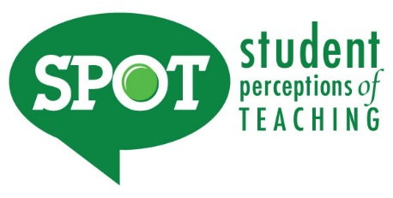
Syllabus Addendum regarding SPOT for FA19 Regular Academic Session/8W1 and 8W2

Student Perceptions of Teaching (SPOT)

Student feedback is important and an essential part of participation in this course. The student evaluation of instruction is a requirement for all organized classes at UNT. The SPOT survey will be made available November 18 – December 5 to provide you with an opportunity to evaluate how this course is taught. For the fall 2019 semester you will receive an email on November 18 (12:01 a.m.) from "UNT SPOT Course Evaluations via IASystem Notification" (no-reply@iasystem.org) with the survey link. Please look for the email in your UNT email inbox. Simply click on the link and complete your survey. Once you complete the survey you will receive a confirmation email that the survey has been submitted. For additional information, please visit the SPOT website at www.vpaa.unt.edu/spot or email spot@unt.edu.

Student Perceptions of Teaching (SPOT)

Student feedback is important and an essential part of participation in this course. The student evaluation of instruction is a requirement for all organized classes at UNT. The SPOT survey will be made available October 7 – October 17 to provide you with an opportunity to evaluate how this course is taught. For the 8W1 fall 2019 semester you will receive an email on October 7 (12:01 a.m.) from "UNT SPOT Course Evaluations via IASystem Notification" (no-reply@iasystem.org) with the survey link. Please look for the email in your UNT email inbox. Simply click on the link and complete your survey. Once you complete the survey you will receive a confirmation email that the survey has been submitted. For additional information, please visit the SPOT website at www.vpaa.unt.edu/spot or email spot@unt.edu.
Student Perceptions of Teaching (SPOT)

Student feedback is important and an essential part of participation in this course. The student evaluation of instruction is a requirement for all organized classes at UNT. The SPOT survey will be made available December 2 – December 12 to provide you with an opportunity to evaluate how this course is taught. For the 8W2 fall 2019 semester you will receive an email on December 2 (12:01 a.m.) from "UNT SPOT Course Evaluations via IASystem Notification" (no-reply@iasystem.org) with the survey link. Please look for the email in your UNT email inbox. Simply click on the link and complete your survey. Once you complete the survey you will receive a confirmation email that the survey has been submitted. For additional information, please visit the SPOT website at www.vpaa.unt.edu/spot or email spot@unt.edu.

